Separation of Reverse Phase Text Mixture and Determination of Caffeine Concentration in Commercial Beverage by High-Performance Liquid Chromatography

Max Shi

*Department of Chemistry, Stevens Institute of Technology, Castle Point on Hudson, Hoboken, NJ 07030.*

*Performed November 16, 2020, submitted November 25, 2020.*

**Abstract:** In this two-part experiment, High-Performance Liquid Chromatography (HPLC) was used to separate compounds in a reverse phase test mixture made from uracil, acetophenone, methyl benzoate, toluene, and naphthalene, and was used to determine the concentration of caffeine in a commercial cola beverage using calibration solutions with benzophenone as an internal standard.

In the first part of the experiment, the HPLC machine was set up and the test mixture was injected. Based on the UV spectra of each peak, the compounds in the test mixture were assigned to each chromatographic peak. The compounds eluted in the same order as shown above, which shows the decreasing polarity of the compounds in that order.

In the second part of the experiment, equal parts of 1.000 mM benzophenone, 1.000 mM caffeine, and 1.000 mM benzoic acid were mixed together, and injected into the HPLC loop. With the areas and known concentrations, the molar response ratio of caffeine and benzoic acid to the benzophenone internal standard were calculated to be 0.189 and 9.35E-03, respectively. Next, four solutions of 0.2, 0.4, 0.6, and 0.8 mM caffeine were created with the 1.000 mM caffeine stock solution, and each solution was mixed with an equal part of 0.2 mM benzophenone. Then, each solution’s chromatogram was recorded, and their peak areas were measured. Similarly, the cola beverage was mixed with equal parts of the 0.2 mM internal benzophenone standard, and its chromatogram was recorded. Then, by finding the ratios of area and concentration between the caffeine and benzophenone, a calibration plot was calculated, and a relative response factor value was found. Using this value, the concentration of caffeine in the cola beverage was calculated to be 0.596 mM.

**Introduction**

High-Performance Liquid Chromatography (HPLC) is a technique used to separate mixtures into their components, allowing for qualitative and quantitative analysis on the mixture and its components as a whole. As this is a form of chromatography, the same concept still applies, where compounds are separated by interactions between the mobile phase and stationary phase and analyzed by response intensity and retention time in the column.

In HPLC, a liquid is used as the mobile phase in this technique, which is usually water, acetonitrile, methanol, or a mixture of those compounds. This mobile phase carries the analyte through the column, which in this experiment, was a reverse phase column. In this type of column, the walls are coated with octadecylsilyl coated silica, rendering the silica nonpolar. Therefore, polar compounds would move freely through the column compared to more nonpolar compounds, which results in more polar compounds eluting first out of the system.

The intensity of the peaks measured by the HPLC machine can also be used to determine the unknown concentration of a known substance using a calibration plot and an internal standard. By mixing solutions of different concentrations of an analyte with a solution of a fixed concentration of internal standard, and measuring chromatograms of each solution, a relationship between the concentration ratio and area ratio between the analyte and internal standard can be set up, and a regression plot can be created. Then, after adding the internal standard to the unknown, the same analysis can be done to the peak corresponding to the analyte in the unknown, which should be easily identifiable as the retention time should be similar. With the calibration plot, the unknown concentration can be determined.

**Results and Discussion**

For the first part of this experiment, an Agilent 1100 Liquid Chromatograph with diode array UV detector was used. The reverse phase test mixture and HPLC grade solvents of water (CAS#: 7732-18) and acetonitrile (CAS#: 75-05-08) were provided by the TAs.

The machine was set up to perform a 50:50 water:acetonitrile isocratic run, and 10 µL of the reverse phase test mixture was injected into the system with a syringe. A chromatogram was recorded at 254 nm. Figure 1 shows the chromatogram recorded.



Figure 1: Chromatogram of Reverse Phase Test Mixture

Analysis of the peaks at 1.759 minutes, 3.431 minutes, 4.317 minutes, 6.497 minutes, and 7.711 minutes yields Figures 2-6.

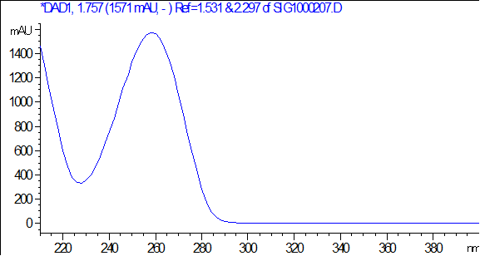

Figure 2: UV Absorption Spectra at 1.759 Minutes

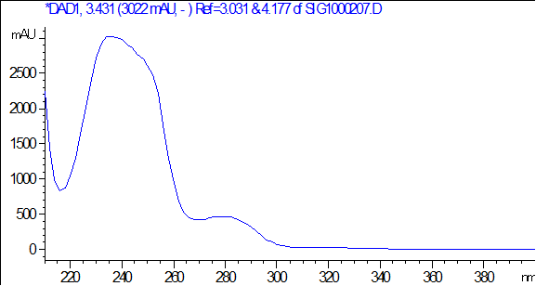

Figure 3: UV Absorption Spectra at 3.431 Minutes

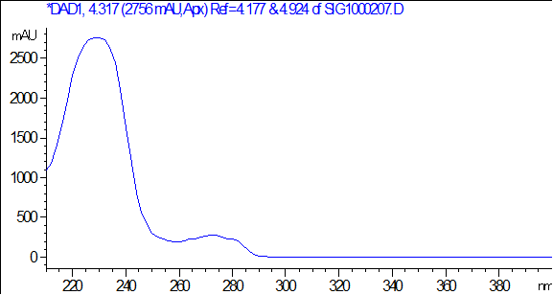

Figure 4: UV Absorption Spectra at 4.317 Minutes

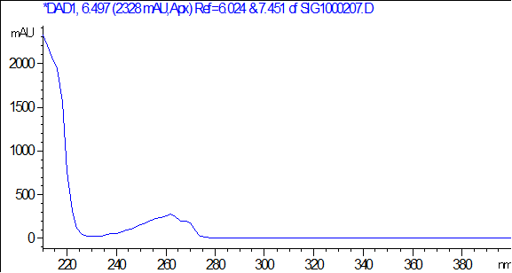

Figure 5: UV Absorption Spectra at 6.497 Minutes

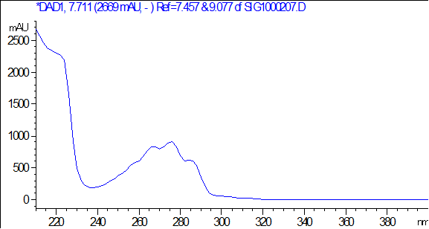

Figure 6: UV Absorption Spectra at 7.711 Minutes

Using λmax values from online resources, the Table 1 was generated.

Table 1: Structures and Maximum Absorption Wavelengths of Reverse Phase Test Mixture

|  |  |  |
| --- | --- | --- |
| **Compound** | **Structure** | **λmax (nm)** |
| Uracil |  | 258-260 |
| Acetophenone |  | 243 |
| Methyl Benzoate |  | 227 |
| Toluene |  | 207, 260 |
| Naphthalene |  | 221, 275.5, 286 |

Matching up these maximum wavelengths to the UV spectra recorded yields the same order as the table was presented. Figure 2 sees a peak around 260 nm, which identifies it as uracil. Figure 3 sees a peak around 240 nm, which puts it closest to acetophenone. Figure 4 has a peak around 230 nm, closest to methyl benzoate. Figure 5 has a peak at 260 nm, coming down from what could be a large peak at 207 nm, though that is not on the spectra recorded, putting this spectra in correlation with toluene. Figure 6 has the peaks at 221, 275.5, and 286 nm as described by naphthalene. While the original chromatogram was measured at 254 nm, the different λmax values are a result of the different chromophores in each of these compounds. Because most of these chromophores absorb at some degree around 254 nm, this was a suitable wavelength for the analysis of this mixture. Furthermore, based on the elution order of this compound, it can be concluded that uracil is the most polar compound in this mixture, while naphthalene is the least polar, with each compound in between being in order of decreasing polarity.

For the second part of this experiment, 1.000 mM benzophenone (CAS#: 119-61-9), benzoic acid (CAS#: 65-85-0), and caffeine (CAS#: 58-08-2) solutions were provided by the TAs. To begin, 5.00 mL of each solution was pipetted into a 25-mL conical flask, and 30 µL was injected into the HPLC injection loop. A chromatogram was recorded of this mixture shown in Figure 7 along with the peak areas.

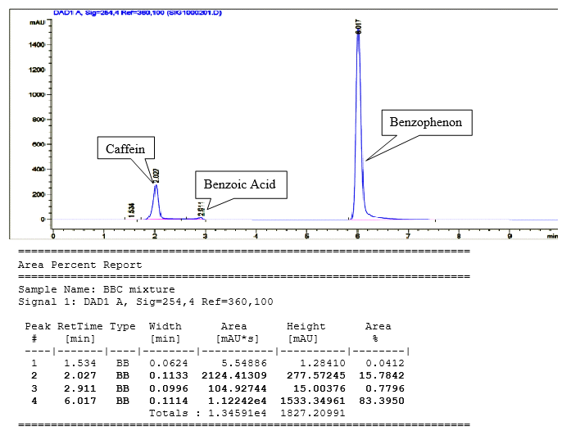

Figure 7: Chromatogram and Peak Areas of Benzoic Acid, Caffeine, and Benzophenone Mixture

With that data, the following Table 2 was created, and the molar response ratios of caffeine and benzoic acid in comparison to the benzophenone internal standard was created.

Table 2: Molar Response Ratio

|  |  |  |  |  |
| --- | --- | --- | --- | --- |
| Substance | Peak Area | Relative Area | Ratio of Conc. | Molar Response Ratio |
| Caffeine | 2124.41309 | 1.89E-01 | 1 | 1.89E-01 |
| Benzoic Acid | 104.92744 | 9.35E-03 | 1 | 9.35E-03 |
| Benzophenone (IS) | 11224.20 | 1 | 1 | 1 |

Then, from the 1.000 mM caffeine solution, 25 mL 0.2, 0.4, 0.6, and 0.8 mM solutions of caffeine were created by diluting 5, 10, 15, and 20 mL of stock solution to 25 mL with deionized water. Then, 10.00 mL of each of these solutions were mixed with 10.00 mL 0.2 mM benzophenone solution to get four calibration mixtures of 0.1, 0.2, 0.3, and 0.4 mM caffeine, respectively. 30 µL of each calibration mixture was injected into the HPLC machine, and chromatograms were recorded. Finally, 10.00 mL of the cola beverage was mixed with 10.00 mL 0.2 mM benzophenone, and 30 µL of that mixture was also injected, and a chromatogram was recorded. The chromatograms and peak areas are reported in Figures 8-12.

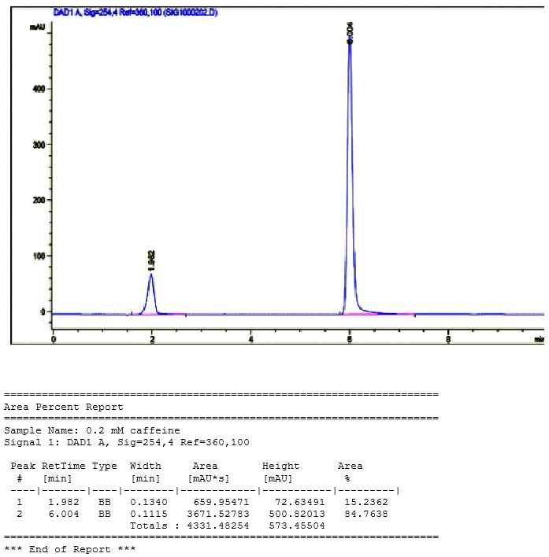

Figure 8: Chromatogram and Peak Areas of 0.2 mM Mixture

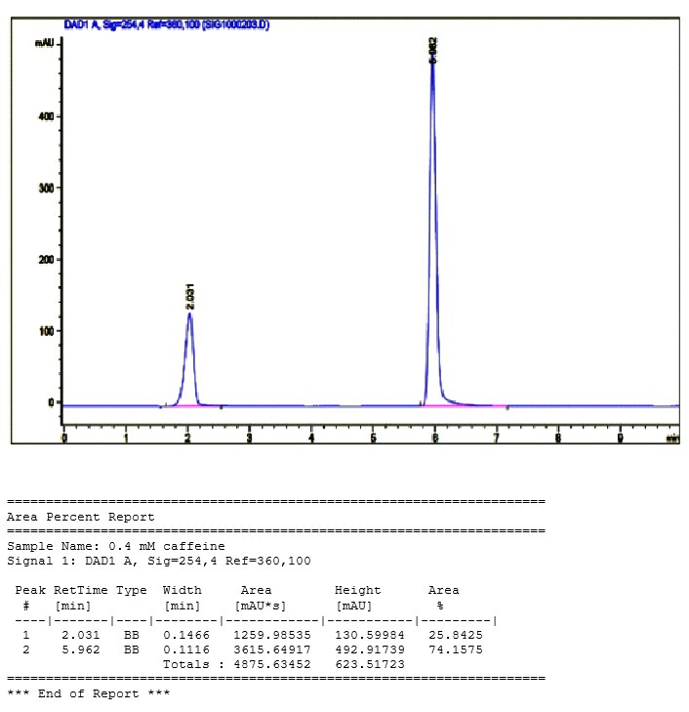

Figure 9: Chromatogram and Peak Areas of 0.4 mM Mixture

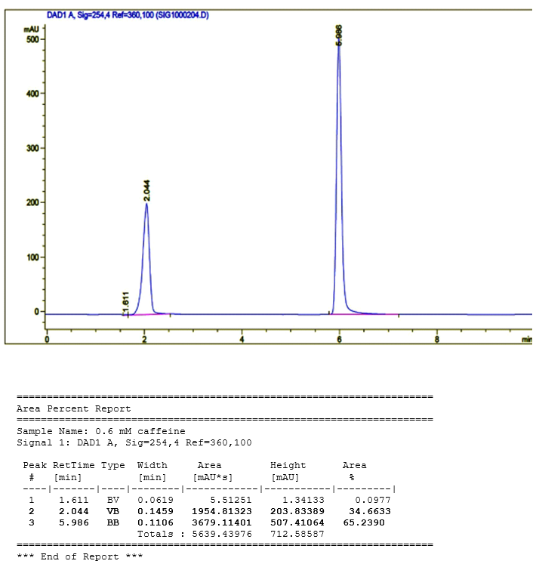

Figure 10: Chromatogram and Peak Areas of 0.6 mM Mixture

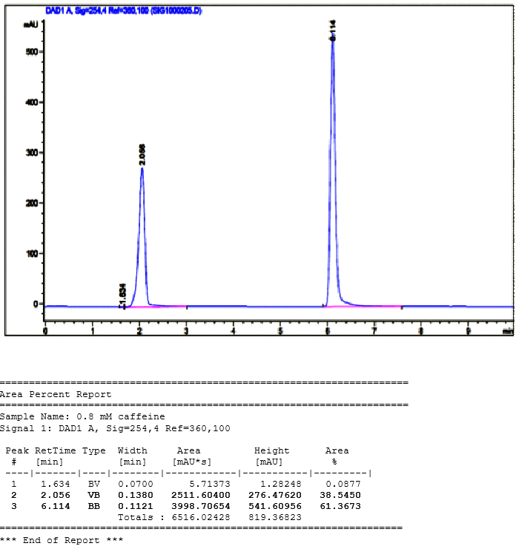

Figure 11: Chromatogram and Peak Areas of 0.8 mM Mixture

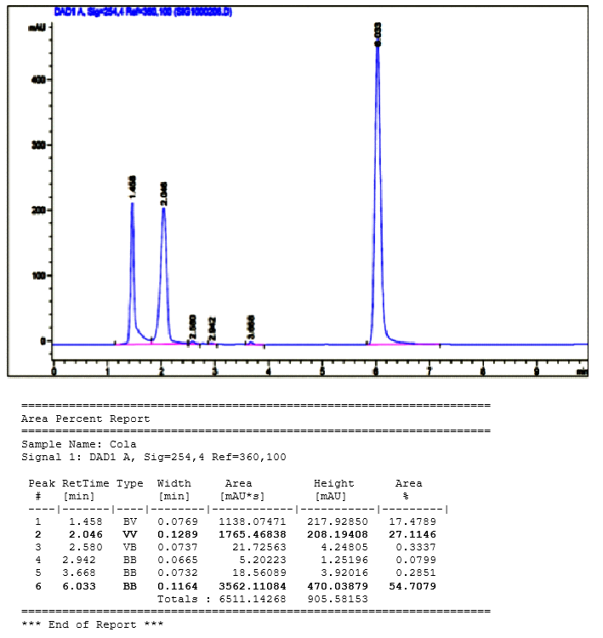

Figure 12: Chromatogram and Peak Areas of Cola and IS Mixture

As the original benzophenone and caffeine solutions were diluted in equal parts, their actual concentrations are halved from their original concentrations. With this information and the measured peak areas, the following Table 3 was created.

Table 3: RRF Calculation Table

|  |  |  |  |  |  |
| --- | --- | --- | --- | --- | --- |
| Caffeine Conc. (mM) | Peak Area of Caffeine (AU) | Benzophenone  Conc. (mM) | Peak Area of  Benzophenone Signal (AU) | Area (Caffeine) /  Area (IS) | Conc. (Caffeine) /  Conc. (IS) |
| 0.1 | 659.95471 | 0.1 | 3671.52783 | 0.179749342 | 1 |
| 0.2 | 1259.98535 | 0.1 | 3615.64917 | 0.348481086 | 2 |
| 0.3 | 1954.81323 | 0.1 | 3679.11401 | 0.531327169 | 3 |
| 0.4 | 2511.604 | 0.1 | 3998.70654 | 0.628104107 | 4 |
| Unknown | 1765.46838 | 0.1 | 3562.11084 | 0.495624213 | Unknown |

By plotting the area ratios against the concentration ratios and creating a regression line according to the following Equations 1 and 2, the following graph was created, depicted in Figure 13.

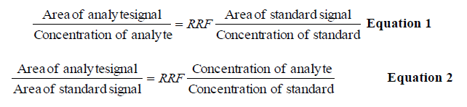

Figure 13: Calibration Plot for Caffeine vs IS

Using the area ratio for the unknown compound, plugging this in for y yields a concentration ratio of 2.982. Multiplying by the benzophenone concentration of 0.1 mM recovers a caffeine concentration of 0.298 mM in the injected mixture. Because this was originally mixed in a 1:1 mixture, doubling this concentration will yield the original concentration of caffeine in the cola, which is 0.596 mM.

**References**

1. Acetophenone | C6H5COCH3 - PubChem <https://pubchem.ncbi.nlm.nih.gov/compound/Acetophenone#section=Other-MS> (accessed Nov 25, 2020).
2. Attygalle, A. Instrumental Analysis I Lecture and Laboratory Manual <https://sit.instructure.com/courses/38802/files/6982711?module_item_id=1042514> (accessed Nov 25, 2020).
3. Certificate Of Analysis <https://www.sigmaaldrich.com/catalog/CertOfAnalysisPage.do?symbol=U0750&LotNo=55H1068&brandTest=SIGMA> (accessed Nov 25, 2020).
4. Harris, D. C. *Quantitative Chemical Analysis*, 8th ed.; W.H. Freeman and Co: New York, 2010. Chapter 24.
5. Methyl benzoate | C6H5COOCH3 - PubChem <https://pubchem.ncbi.nlm.nih.gov/compound/Methyl-benzoate#section=EI-MS> (accessed Nov 25, 2020).
6. Naphthalene | C10H8 - PubChem <https://pubchem.ncbi.nlm.nih.gov/compound/Naphthalene#section=Other-MS> (accessed Nov 25, 2020).
7. Toluene | C6H5CH3 - PubChem <https://pubchem.ncbi.nlm.nih.gov/compound/Toluene#section=EI-MS> (accessed Nov 25, 2020).